1 A.) One of ways I thought about sorting the student by using a modified version of heap sort. I chose heap sort as it is a very fast algorithm, but also since it requires low amounts of memory when compared to other algorithms such as merge sort, since my solution requires a huge amounts of structures (880) I thought that this would be very beneficial.
My second solution involved using insertion sort. I came to the conclusion of using insertion sort as it too efficient on memory as it doesn’t require much temporary memory, but also it isn’t very complex so it was I was able to modify to sort the students and hold the records without causing the code to become less efficient.

B.) I believe the most suited data structures are arrays within a structure, as this can keep track of a lot of data at once e.g. We can store a student’s Name, Year and Name within a single structure. Structures also make it very easy to transfer/copy data.

C.)FIRST SOLUTION
http://www.personal.kent.edu/~rmuhamma/Algorithms/MyAlgorithms/Sorting/heapSort.htm
My first solution I modified heap sort to sort the student, first by year, it then sort them into different structures. I also modified it to also move the student numbers as it moves the year(e.g. if it moves an element in the array “year” it moves the corresponding element in “studentnum” as not to mix up the students, i.e. if the contents of “year[220]” is swapped with the contents of “year[100]” , then the contents in “studentnum[220]” is swapped with the contents of “studentnum[100]” ) This allows us to track a certain student if necessary.
The algorithm starts off with single “student structs” being copied into the “master struct” where the sorting will take place

for (i = 0, i < 440, i++)
master.year[i] = student[i].year
master.studentnum[i] = student[i].studentnum
end for

This algorithm continues as it heap sort usually would, from a top downward approach where we insert array values into the “heap” ,but, I added the extra lines, it essentially mimics the movement that the code that sorts the years, as so it would actually not sort their studentnumber based on their numerical value but based on their “year” counterpart.

for(i = 1, i < 440, i++)
c = i
do
root = (c - 1) / 2
if (master.year[root] < master.year[c])
temp = master.year[root]
studtemp = master.studentnum[root]

master.year[root] = master.year[c]
master.studentnum[root] = master.studentnum[c]

master.year[c] = temp
master.studentnum[c] = stutemp
end if
c = root
end do while ( c != 0 )
end for

for (j = 440 -1, j >= 0, j--)
temp = master.years[0]
stutemp = master.studentnum[0]

master.year[0] = master.year[j]
master.studentnum[0] = master.studentnum[j]

master.year[j] = temp
master.studentnum[j] = stutemp

root = 0
do
c = 2 * root + 1
if((master.year[root] < heap[c+1]) && c < j -1)
c++
end if
if (master.year[root] < master.year[c] && c < j)
temp = master.yeat[root]
stutemp = master.student[root]

master.year[root] = master.year[c]
master.studentnum[root] = master.studentnum[c]

master.year[c] = temp
master.srudentnum[c] = stutemp
end if
root = c
end do while (c < j)
end for

When the “year” array is sorted, the second final part of the algorithm sorts them into their respective 1st , 2nd , 3rd or 4th year structures respectively, by way of a loop and if statements

for (i = 0, i < 440, i++)
if(master.years[i] == 1)
year1.studentnum[i] = master.studentnum[i]
end if

if(master.years[i] == 2)
year2.studentnum[i] = master.studentnum[i]
end if

if(master.years[i] == 3)
year3.studentnum[i] = master.studentnum[i]
end if

if(master.years[i] == 4)
year4.studentnum[i] = master.studentnum[i]
end if
end for
________________________________________________________________________________
(FLOWCHARRT FOR SOLUTION 1 IN QUETION E)
C.)SECOND SOLUTION
http://www.mathcs.emory.edu/~cheung/Courses/170/Syllabus/09/sel-sort.html
My second solutions follows the same guide lines as my first solution. It too takes the single student structure and puts it into the “master” structure

for(i = 0, i < 440, i++)
master.year[i] = student[i].year
master.studentnum[i] = student[i].studentnum
end for

Like in my other solution I added more lines to move the “studentnum” counterpart in the array “year” so that “linked” together and so we could track specific students

for(i=1;i<440;i++)

temp=master.year[i]
stutemp = master.studentnum[i]

j=i-1

while((temp<a[j])&&(j>=0))

master.year[j+1] = master.year[j];
master.studentnum[j+1] = master.studentnum[j];

j=j-1;
end while

master.year[j+1] = temp;
master.studentnum[j+1] = stutemp;
end for

When the “year” array is sorted, the second final part of the algorithm sorts them into their respective 1st , 2nd , 3rd or 4th year structures respectively, by way of a loop and if statements

for (i = 0, i < 440, i++)
if(master.years[i] == 1)
year1.studentnum[i] = master.studentnum[i]
end if

if(master.years[i] == 2)
year2.studentnum[i] = master.studentnum[i]
end if

if(master.years[i] == 3)
year3.studentnum[i] = master.studentnum[i]
end if

if(master.years[i] == 4)
year4.studentnum[i] = master.studentnum[i]
end if
end for
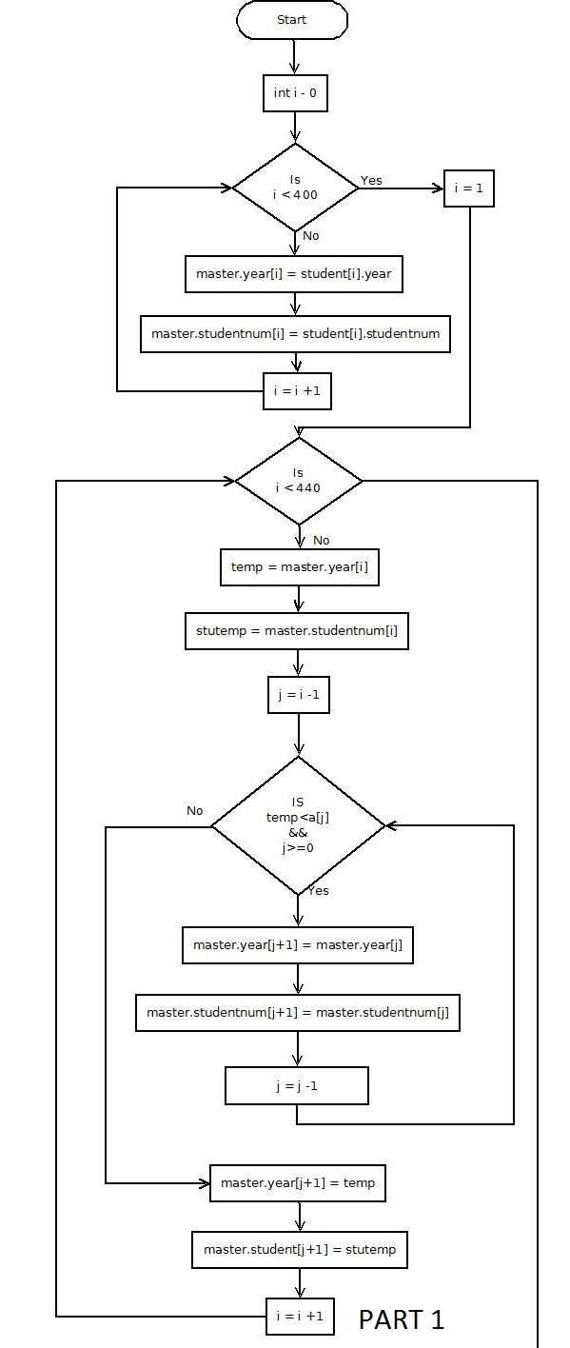
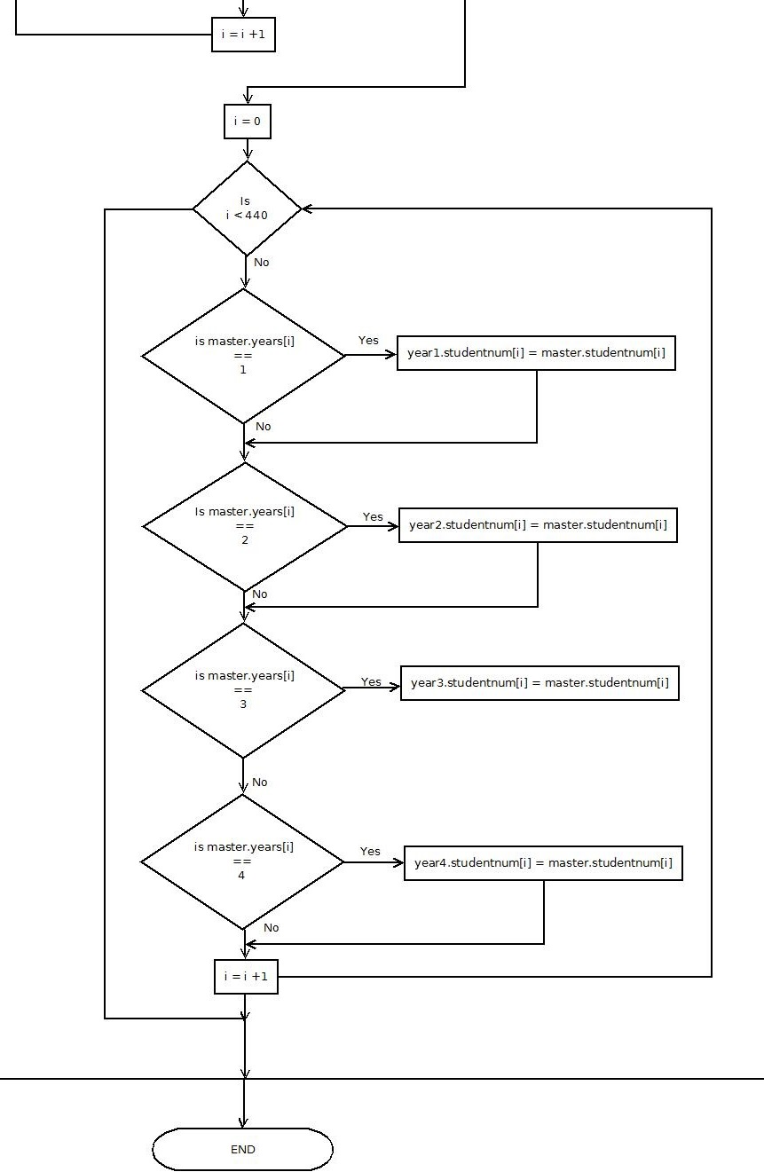
D.)I believe the first solution should be chose due to heap sort being far quicker that insertion sort, especially when it comes to dealing with large amount of numbers, such as we are here. Though the heap sort algorithm is far more complex than the insertion sort algorithm, the heap sort is still relatively easy to follow, even after slight modifications. The bigO of heap sort is O(n Log n), while the bigO of insertion sort is O(n^2)

E.)
for (i = 0, i < 440, i++)
master.year[i] = student[i].year
master.studentnum[i] = student[i].studentnum
end for

for(i = 1, i < 440, i++)
c = i
do
root = (c - 1) / 2
if (master.year[root] < master.year[c])
temp = master.year[root]
studtemp = master.studentnum[root]

master.year[root] = master.year[c]
master.studentnum[root] = master.studentnum[c]

master.year[c] = temp
master.studentnum[c] = stutemp
end if

c = root
end do while ( c != 0 )
end for

for (j = 440 -1, j >= 0, j--)
temp = master.years[0]
stutemp = master.studentnum[0]

master.year[0] = master.year[j]
master.studentnum[0] = master.studentnum[j]

master.year[j] = temp
master.studentnum[j] = stutemp

root = 0
do
c = 2 * root + 1
if((master.year[root] < heap[c+1]) && c < j -1)
c++
end if
if (master.year[root] < master.year[c] && c < j)
temp = master.yeat[root]
stutemp = master.student[root]

master.year[root] = master.year[c]
master.studentnum[root] = master.studentnum[c]

master.year[c] = temp
master.srudentnum[c] = stutemp
end if
root = c
end do while (c < j)
end for

for (i = 0, i < 440, i++)
if(master.years[i] == 1)
year1.studentnum[i] = master.studentnum[i]
end if

if(master.years[i] == 2)
year2.studentnum[i] = master.studentnum[i]
end if

if(master.years[i] == 3)
year3.studentnum[i] = master.studentnum[i]
end if

if(master.years[i] == 4)
year4.studentnum[i] = master.studentnum[i]
end if
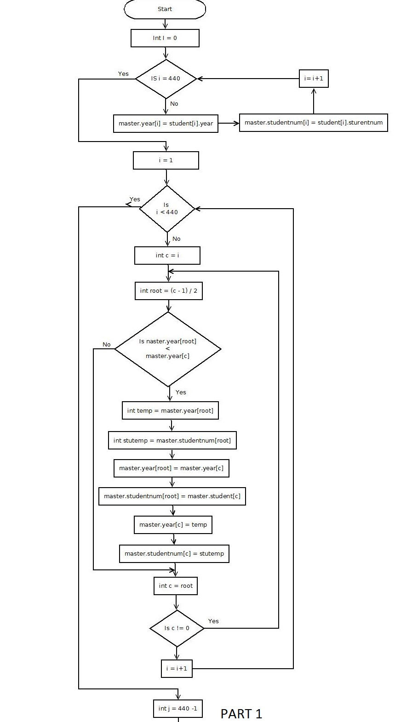
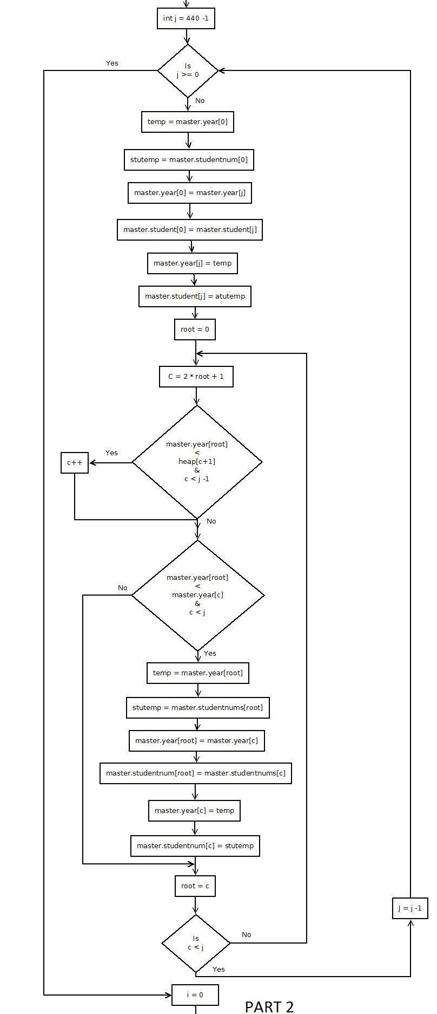
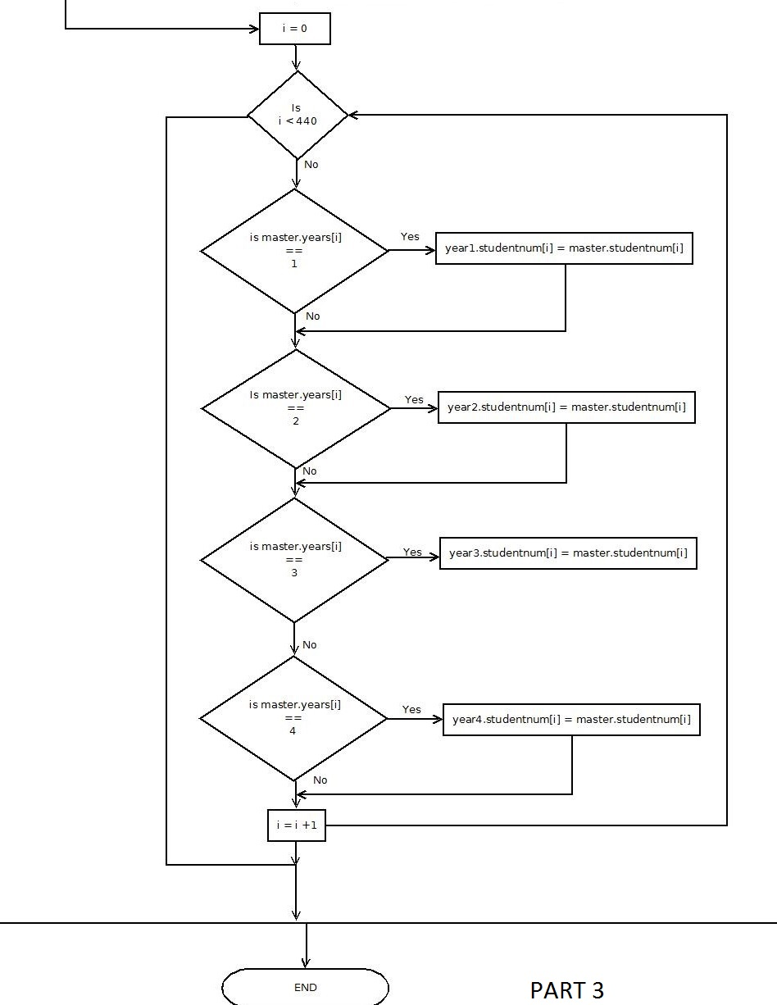

2)
A.) To find certain students I again modified my code from my second solution. I added a string to the “master” struct but also to each of the strcuts that the students fill out their pervious college before joining TU Dublin. As in the pervious solutioin it starts by putting all the students structures into the master struct

for(i = 0, i < 440, i++)
master.year[i] = student[i].year
master.studentnum[i] = student[i].studentnum
master.prevcollege[i] = student[i].prevcollege
end for

Like in my other solutions I added more lines to move the “precollege” counterpart in the array “year” so that were in sync together and so we could track specific students and what colleges the attended before TU Dublin, to do this I needed another temp variable called “stutemp2”

for(i=1, i < 440, i++)
temp=master.year[i]
stutemp = master.studentnum[i]
stutemp2 = master.prevcollege[i]

j=i-1;

while((temp<a[j])&&(j>=0))
master.year[j+1] = master.year[j]
master.studentnum[j+1] = master.studentnum[j]
master.prevcollege[j+1] = master.prevcollege[i]

j=j-1

end while

master.year[j+1] = temp
master.studentnum[j+1] = stutemp
master.prevcollege[j+1] = stutemp2
end for

In my pervious solution I sorted the students by what year they were in at the end, but since we had to search for specific students depending what college they were previously attending.

for (i = 0, i < 440, i++)
if(master.prevcollege[i] = "DIT" )
DIT.studentnum[i] = master.studentnum[i]
end if

if(master.prevcollege[i] = "ITT" )
ITT.studentnum[i] = master.studentnum[i]
end if

if(master.prevcollege[i] = "ITB" )
ITB.studentnum[i] = master.studentnum[i]
end if

end for

Now that they have been sorted by college, we can now easily find the described student.

3B.)
for(i = 0, i < 440, i++)
master.year[i] = student[i].year
master.studentnum[i] = student[i].studentnum
master.prevcollege[i] = student[i].prevcollege
end for

for(i=1, i < 440, i++)
temp=master.year[i]
stutemp = master.studentnum[i]
stutemp2 = master.prevcollege[i]

j=i-1;

while((temp<a[j])&&(j>=0))
master.year[j+1] = master.year[j]
master.studentnum[j+1] = master.studentnum[j]
master.prevcollege[j+1] = master.prevcollege[i]

j=j-1

end while

master.year[j+1] = temp
master.studentnum[j+1] = stutemp
master.prevcollege[j+1] = stutemp2
end for

for (i = 0, i < 440, i++)
if(master.prevcollege[i] = "DIT" )
DIT.studentnum[i] = master.studentnum[i]
end if

if(master.prevcollege[i] = "ITT" )
ITT.studentnum[i] = master.studentnum[i]
end if

if(master.prevcollege[i] = "ITB" )
ITB.studentnum[i] = master.studentnum[i]
end if

end for

